Maoam Spender
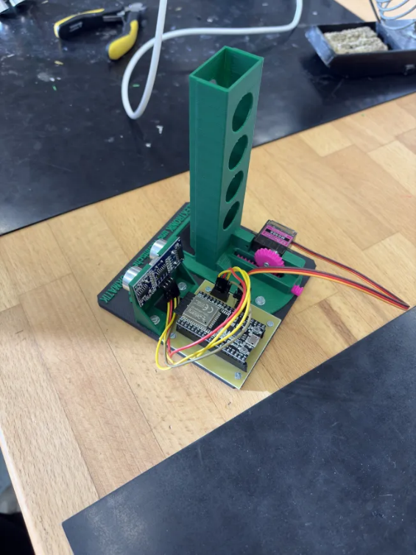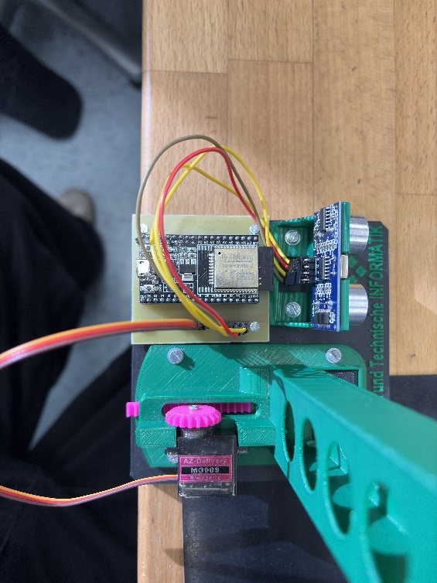

Code:
#include <Arduino.h>
#include <ESP32Servo.h>

const int trigPin = 22;
const int echoPin = 23;
Servo myServo;
const int servoPin = 16;
long duration;
int distance;

void setup() {
Serial.begin(115200);

pinMode(trigPin, OUTPUT);
pinMode(echoPin, INPUT);

myServo.attach(servoPin);
myServo.write(180); //Servo auf 180 Grad setzen
}

void loop() {
digitalWrite(trigPin, LOW);
delayMicroseconds(2);
digitalWrite(trigPin, HIGH);
delayMicroseconds(10);
digitalWrite(trigPin, LOW);

duration = pulseIn(echoPin, HIGH, 30000);
distance = duration * 0.034 / 2;

Serial.print("Sensorwert (Dauer): ");
Serial.print(duration);
Serial.print(" µs | ");

Serial.print("Entfernung: ");
Serial.print(distance);
Serial.println(" cm");

if (distance > 0 && distance < 15) {
myServo.write(0);
delay(500);
} else {
myServo.write(180);
}

delay(200);
}

